**Ideation Phase**

**Brainstorm & Idea Prioritization Template**

|  |  |
| --- | --- |
| Date | 30 October 2025 |
| Team ID | NM2025TMID00370 |
| Project Name | Streamlining Ticket Assignment for Efficient Support Operations. |
| Maximum Marks | 4 Marks |

**Brainstorming & Idea Prioritization Template:**

Brainstorming encourages collaborative creativity to identify innovative ways to improve support efficiency. For this project, our goal was to design an automated ticket assignment system using **ServiceNow** that ensures faster, more accurate issue resolution while balancing workloads among support agents.

The brainstorming session helped us analyze existing challenges in manual ticket routing and develop data-driven ideas to optimize the support workflow.

**Step 1: Team Gathering, Collaboration and Problem Selection:**

Our team discussed common issues in IT support operations, particularly the delay and inefficiency caused by manual ticket assignment. After analyzing several problem areas, we selected **“Streamlining Ticket Assignment”** as our focus area.

The main objective was to automate ticket routing based on agent skills, workload and priority—reducing response times and improving customer satisfaction.

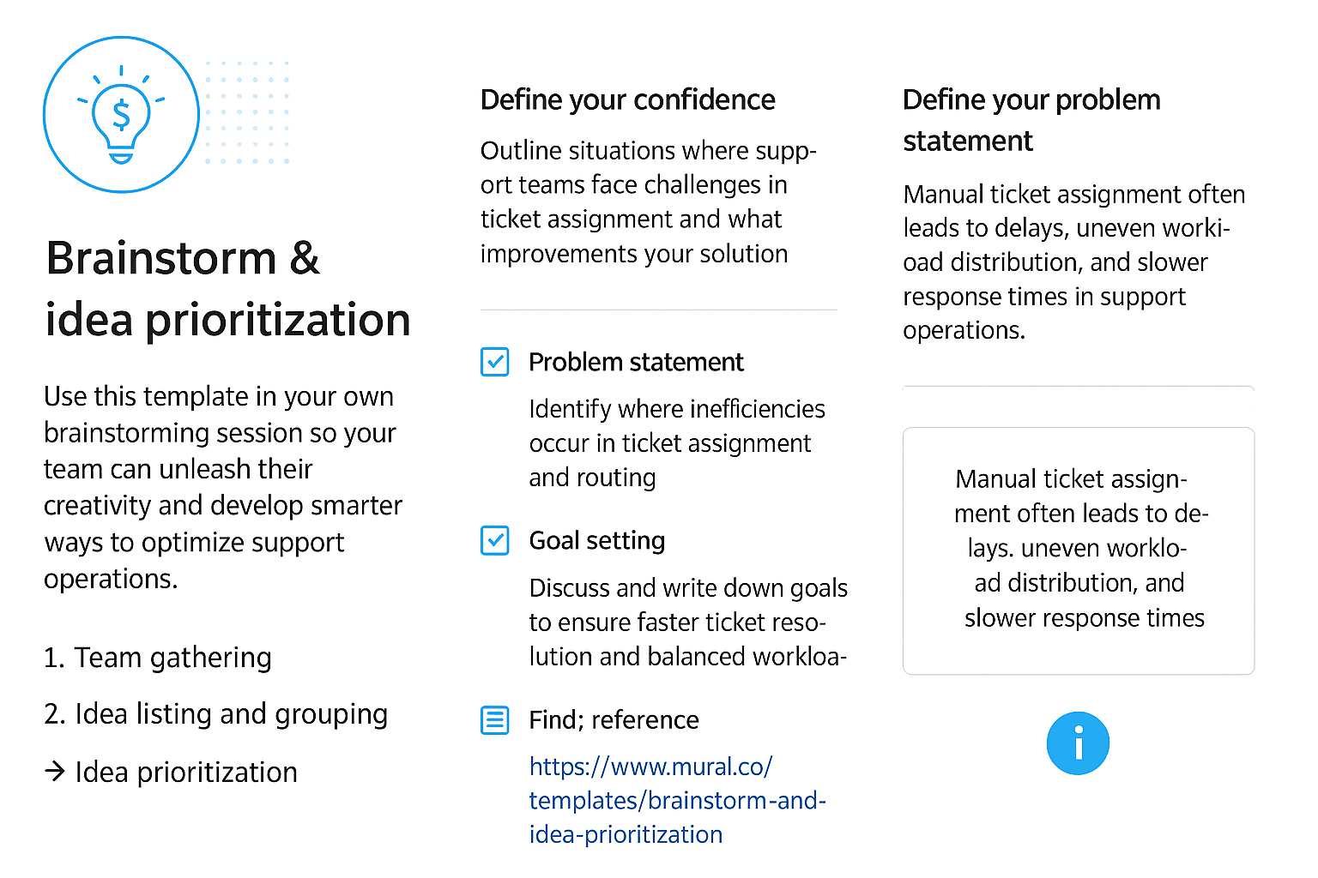

**Step 2: Brainstorming, Idea Listing and Grouping:**

We listed all possible ideas to automate and enhance the ticket assignment process using ServiceNow. Each idea was discussed, grouped and evaluated for technical feasibility and potential impact.

**Ideas generated included:**

* Automating ticket assignment based on agent skill sets and availability.
* Implementing a priority-based routing mechanism (e.g., critical, high, medium, low).
* Integrating AI/ML models to predict and assign tickets dynamically.
* Creating real-time dashboards to monitor ticket load per agent/team.
* Sending automated notifications and SLA reminders to ensure timely resolution.
* Enabling escalation workflows for unresolved tickets.

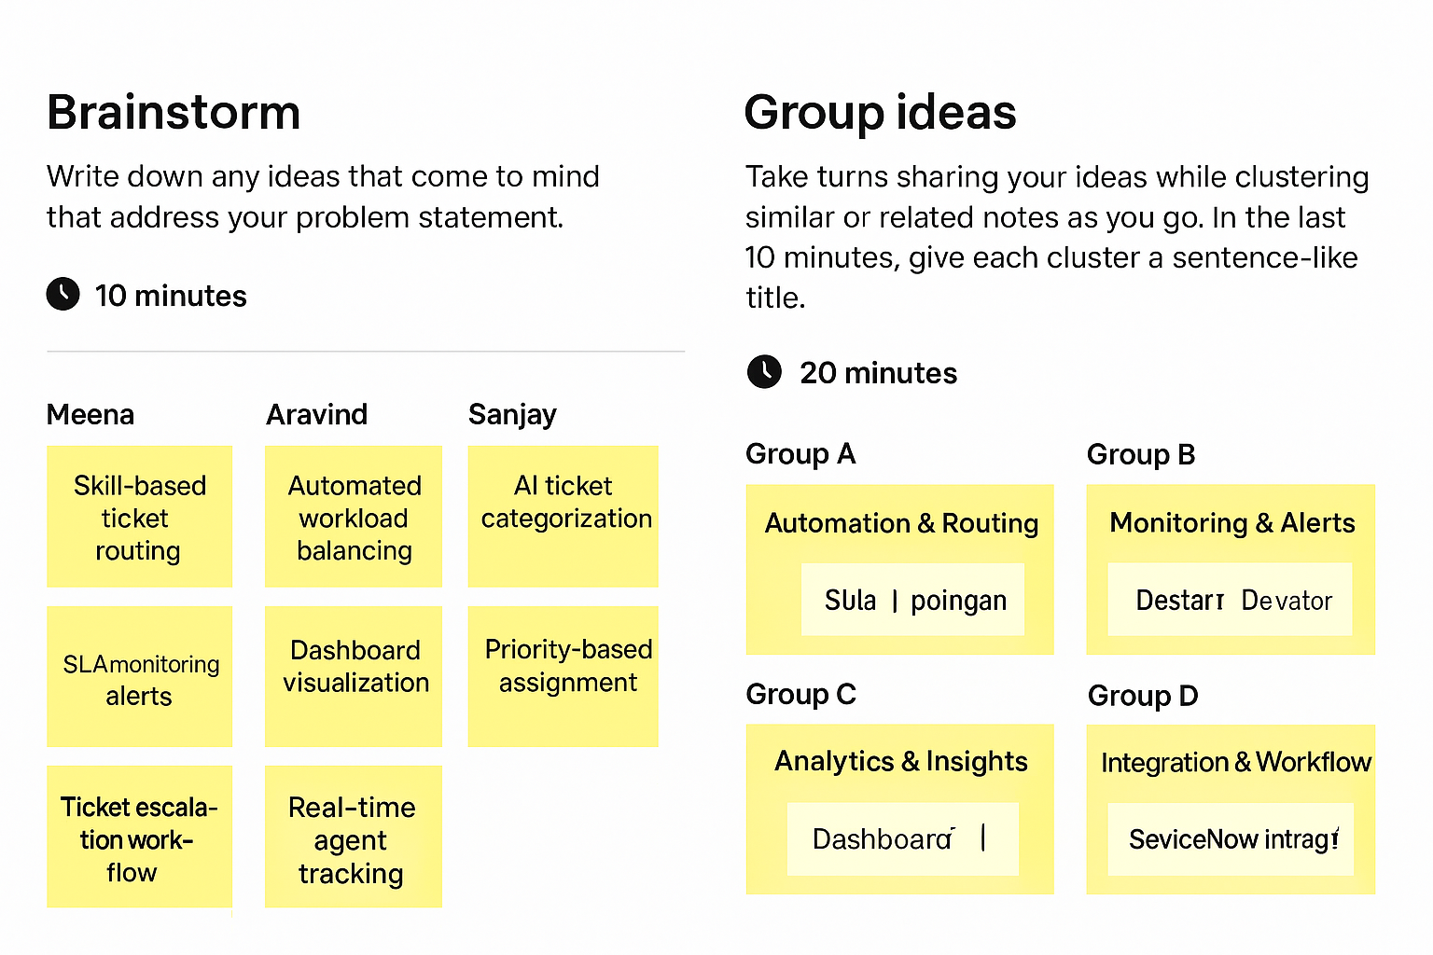.

**Step 3: Idea Prioritization:**

After listing all ideas, we applied impact vs. feasibility analysis to prioritize key solutions for implementation. High-impact and easily deployable features were chosen for the initial phase.

**Prioritized ideas:**

* Automated ticket assignment based on skill and workload.
* Real-time dashboard for workload visualization.
* SLA monitoring and automated escalation.
* AI-based ticket prediction and categorization (future enhancement).

